
Smart Attendance Management System
ON
Submitted in partial fulfillment of the requirements
of the degree of
Bachelor of Engineering
(Information Technology)
By
Om Sawlani -Roll No (55)

Under the guidance of
GUIDE NAME

Department of Information Technology
VIVEKANAND EDUCATION SOCIETY’S INSTITUTE OF TECHNOLOGY, Chembur, Mumbai 400074
(An Autonomous Institute, Affiliated to University of Mumbai)

Abstract
This mini-project presents the design and implementation of a Smart Attendance Management System that automates the traditional attendance marking process using Java Swing for the front-end interface and SQL Server for backend data storage.
The system provides functionalities for viewing student details, marking attendance, and generating attendance reports.
It eliminates manual attendance errors, ensures data accuracy, and provides an easy-to-use graphical user interface for academic institutions.

Contents
- Introduction
- Problem Statement
- Objectives
- Proposed Design (Flow Chart)
- Implementation(Logic)
- Results and Analysis
- Conclusion
- References

INTRODUCTION
This project focuses on developing a Java-based Smart Attendance Management System integrated with an SQL Server database.
The system aims to automate and digitize attendance recording for students, replacing manual roll calls.
It utilizes Java Swing to create an interactive GUI that enables users to view student data, mark attendance, and generate attendance reports.
The database is managed through SQL Server Management Studio 21, ensuring secure storage and quick access to records.

PROBLEM STATEMENT
Manual attendance systems are time-consuming and prone to human error or proxy attendance.
Educational institutions require a reliable and automated solution that can efficiently track student attendance, store data in a database, and generate reports on demand.
The proposed system provides an easy-to-use graphical interface connected to a backend database that streamlines the attendance process.

OBJECTIVES
- To design and implement a Java-based GUI for attendance management.
- To integrate the GUI with SQL Server for real-time database operations.
- To automate attendance marking and report generation.
- To ensure data accuracy, accessibility, and security.
- To provide a foundation for further extensions such as biometric integration.

PROPOSED DESIGN

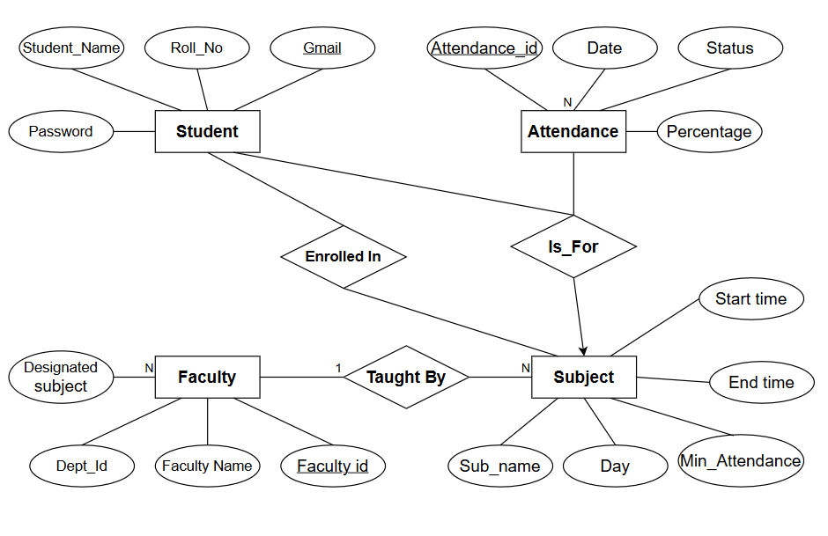
IMPLEMENTATION
The Smart Attendance System was implemented using Java Swing for the graphical user interface and SQL Server Management Studio 21 as the backend database.
The connection between Java and SQL Server was established using JDBC (Java Database Connectivity). The program allows the user to view student records, mark attendance, and generate attendance reports directly through a GUI.
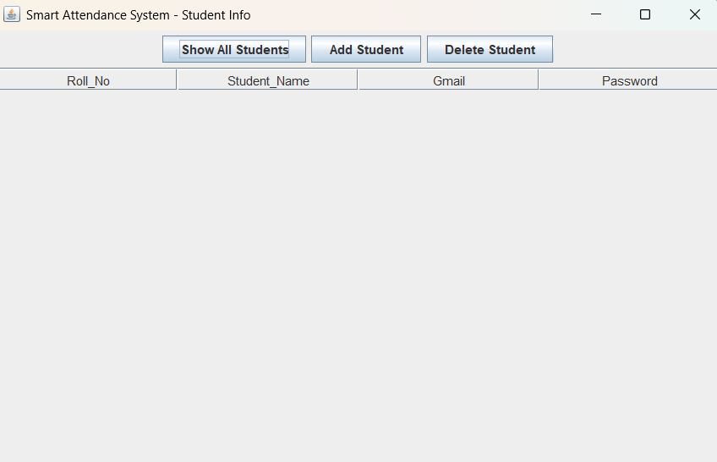
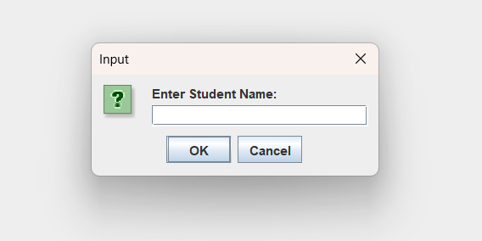
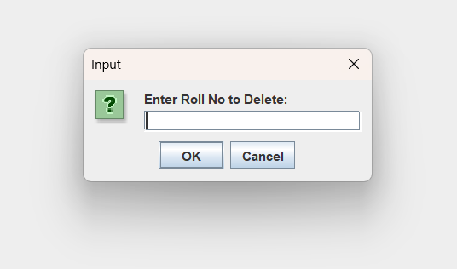
The database contains two main tables — Student and Attendance.
- The Student table stores details such as Roll Number, Name, Gmail, and Password.
- The Attendance table stores Attendance ID, Roll Number, Date, and Status.
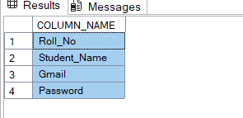
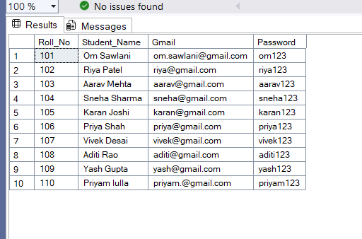
The GUI consists of buttons like Show Students, Mark Present, and Show Report.
Each button performs a specific SQL operation:
- Show Students executes a SELECT query to display all student records.
- Mark Present executes an INSERT query to record attendance for the selected student.
- Show Report executes a JOIN query to combine student and attendance data for reporting.
The system was successfully compiled and executed using the mssql-jdbc-13.2.1.jre11.jar driver. The database operations were reflected in real-time within SQL Server, confirming successful connectivity and data manipulation.

RESULTS AND ANALYSIS

The Smart Attendance Management System was successfully executed using Java Swing and SQL Server Management Studio 21.
The application established a stable connection between the frontend and the backend using JDBC, allowing smooth data transfer and query execution.
When the program was run:
- Clicking on “Show Students” displayed all student details from the Student table.
- Selecting a student and clicking on “Mark Present” inserted a new attendance record in the Attendance table.
- Clicking “Show Report” generated a joined view of both tables, displaying each student’s name, roll number, date, and attendance status.
All the database operations were executed successfully, and the corresponding changes were reflected immediately in SQL Server.
The GUI interface responded without delay, confirming that the system handled multiple operations efficiently.
Thus, the project fulfilled its objective of automating attendance management while maintaining data accuracy, reliability, and ease of use.

CONCLUSION
The Smart Attendance Management System was successfully developed and executed.
The experiment demonstrated how to integrate Java Swing with SQL Server using JDBC to perform real-time database operations through a GUI interface.
The system simplifies attendance management by automating record handling and reduces manual errors.
This project provided a clear understanding of how database connectivity, SQL operations, and graphical interfaces work together to form a complete application.

REFERENCES

[1] "mysql2," npm. [Online]. Available: https://www.npmjs.com/package/mysql2.

[2] "Node.js MySQL Connection," GeeksforGeeks. [Online]. Available: https://www.geeksforgeeks.org/nodejs-mysql-connection/.

[3] "How to Create a Basic REST API in Express.js?," GeeksforGeeks. [Online]. Available: https://www.geeksforgeeks.org/create-a-basic-rest-api-in-express-js/.

